GreekRank:
How a genre has enough power to influence stereotypes and spread hate in college Greek life.

Andie Eckhart
University of Central Florida
ENC1102
Professor Kitty Geoghan

Introduction:
Greek life organizations have been around for nearly 250 years and were started for the sole purpose of furthering academic and social advancements of its members. Sororities and fraternities are value-based organizations that are supposed to hold members accountable in order to establish them into excellent members of society. Greek organizations have many different values ranging from chapter to chapter, but they are all a part of one community which is known as Greek life. “Fraternities and sororities were created as a place to foster academic, community service, and social initiatives that are unique to each chapter. Fraternity and Sorority life is based on the tenets of friendship, leadership, scholarship, and philanthropy” (Frequently Asked Questions). All these members commit time and money to be a part of their chapter and must exhibit certain behaviors to show that they are in it for the right reasons. In recent years with the rise of mainstream media, many problems have become more exposed for communities all around the world. One of these communities being Greek life has caused misperceptions and stereotypes across Greek organizations and overall giving the community an overall bad reputation.
I am interested in seeing how negative stereotypes are encouraged from the media and more specifically the website noted as “GreekRank”. According to the author Payton Toomey, “It’s a website dedicated to ranking and commenting on different sororities and fraternities on campus” (1). In Payton Toomey’s article, “GreekRank is a toxic hellscape of objectification”, she talks about how the main genres of GreekRank are used to promote stereotypes that can cause negative attitudes towards those in Greek life. This source uses rhetorical analysis to study how the different genres apart of this genre set can encourage negative perceptions. This brings to my next source which also uses rhetorical analysis for the sake of further dissecting how different genres help a main genre achieve its goal, which is “The Genres of Chi Omega: An Activity Analysis.” It is interesting as to how she used various research methods including both interviews and rhetorical analysis to understand how the genres used impact the goals they wanted to reach for their sorority. Which differs from other sources judging this study focuses primarily on the genres rather than the actual stereotypes of Greek life.
Going back to the focus of how the media and toxic sites can cause misinterpretation and misinformation of Greek life, brings me to my favorite source being, “Frat Daddies and Sorositutes: How TotalFratMove.com and Greek Identity Influence Greek Student’s Rape Myth Acceptance”. Now, this source relates greatly to other sources I am using in the aspect that it discusses how the internet can reinforce negative attributes of Greek life, but it also differs greatly to other sources I am using in the way that it goes into more of the dark side of stereotypes which include touchy and disturbing subjects like rape culture. This is a very serious issue which is one of the stereotypes attached to Greek life which is why it’s important that there is call to action like the one in this source. That call to action being “Sites such as TFM frequented by fraternity men that perpetuate rape myths and the objectification of sorority women should be of concern to those within the Greek community who are standing up against sexual assault” (Thompson, 2). Clearly, this shows that sites such as TFM should most likely be shut down since they can perpetuate harmful stereotypes especially for women in Greek life. Similarly, in the case study “Evaluating Stereotypes of University Greek Life” and the article known as “Exploring How Popular Media Affects the Motivations and Hesitations of Women Who Go Through Sorority Recruitment at the University of Southern Mississippi”, both sources use rhetorical analysis to look at the approach of how negative connotations or perceptions attached to Greek life are perhaps caused or reinforced. While “Evaluating Stereotypes of Greek Life” focuses less on the mainstream media and more on the physical subjects, which includes both Greek-affiliated students and non-Greek students which also avoids potential bias.
However, “Exploring How Popular Media Affects the Motivations and Hesitations of Women Who Go Through Sorority Recruitment at the University of Southern Mississippi”, the author studies more how the physical media and moreover mass media portrayals of Greek life can push potential or current new members away from it. Lastly, the source that differs the most from previous sources discussed, is the article “Multiple Routes for Social Influence: The Role of Compliance, Internalization, and Social Identity”. This article differs from all the other sources for the prime reason that it focuses on the principles of how social theory impacts decision making for those individually and non-individually. So, this article unlike the rest contains nothing about Greek life or stereotypes but instead assess the sociological aspects of how one’s group identity and independent identity coexist across different continents like Asia and North America. This can be used to show how students’ participation on the website GreekRank is influenced by their group identity being at war with their independent identity.
To wrap it up, the popularization of the media and internet has given downsides to every community but addressing those can resolve the conflict rather than turn a blind eye. Each of these authors, used rhetorical analysis to study the genres and their corresponding moves attached to them. Some scholars found more success through interview or surveys, but overall utilizing rhetorical analysis can show the crucial aspects that may usually be overlooked in research.

Methods:
I decided on using the method of rhetorical analysis to dissect the comments in the discussion genre as shown highlighted below. I chose about thirty comments to analyze and made sure that these were all from pages about a month from each other. It was also very important that I made sure to avoid any bias given that I am a student apart of Greek life myself. Once I collected the comments, I used coding to establish the main feelings of the comments. This was done to better understand the purpose or intent of those comments. Assigning codes to these comments helped me group similar comments together accordingly. With the comments then grouped together I can then easily make connections to express how they provide evidence for my research question. I coded these through looking at similar purposes, titles, or words that were in the posts.

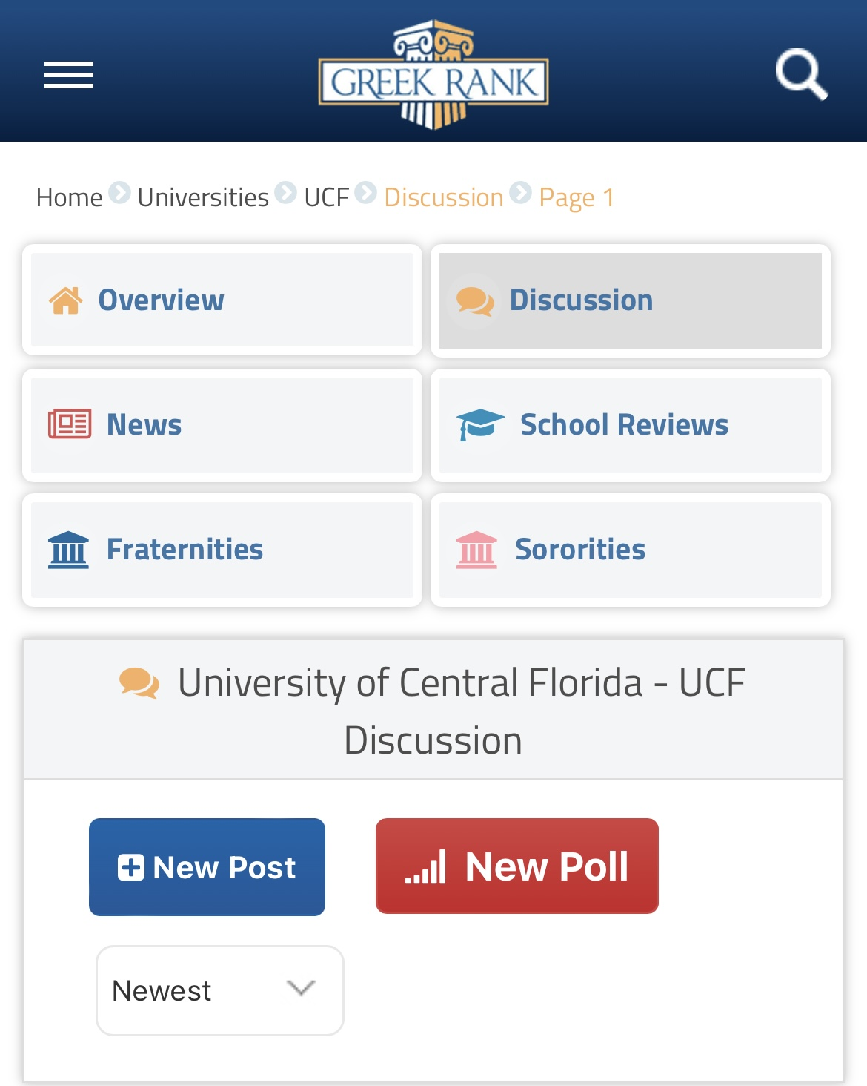
(“University of Central Florida – UCF Discussion”)

Results:

Gossip/spreading hate
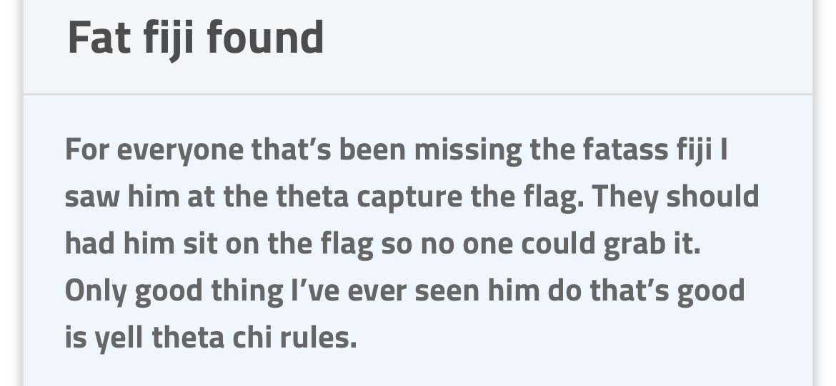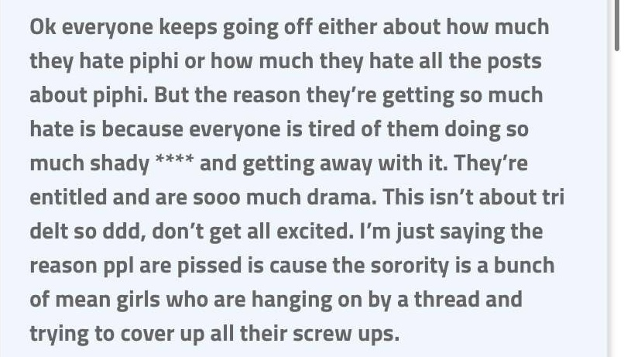
(“Fat Fiji Found”) (“So many piphi posts BFFR”)
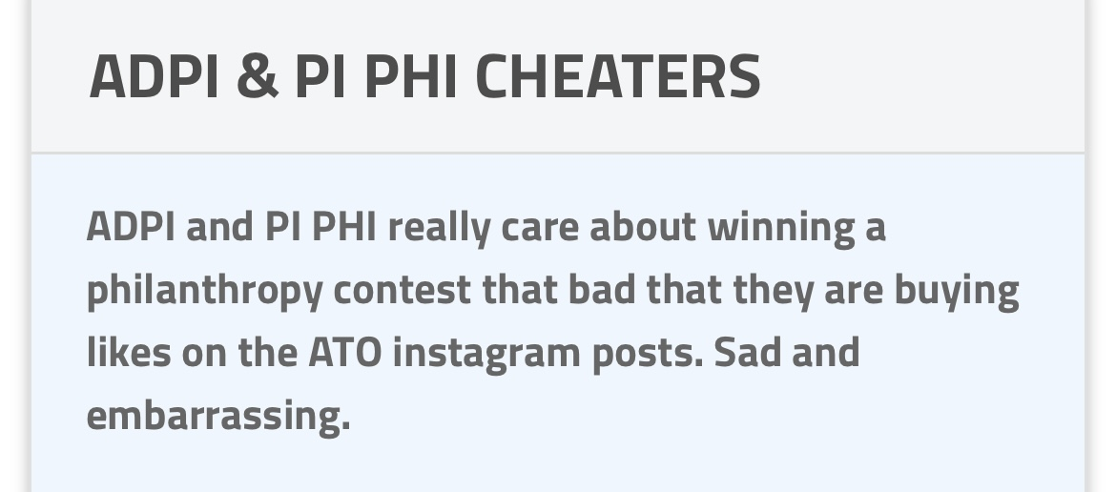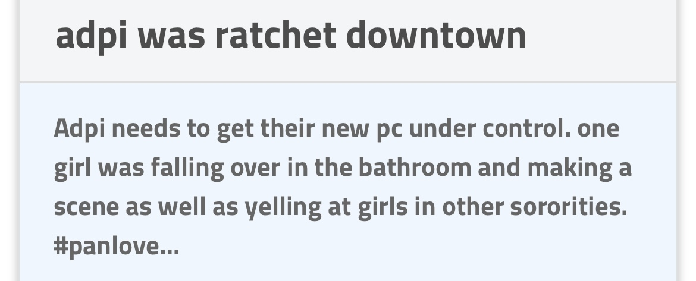
(“ADPI & PI PHI CHEATERS”) (“adpi was ratchet downtown”)
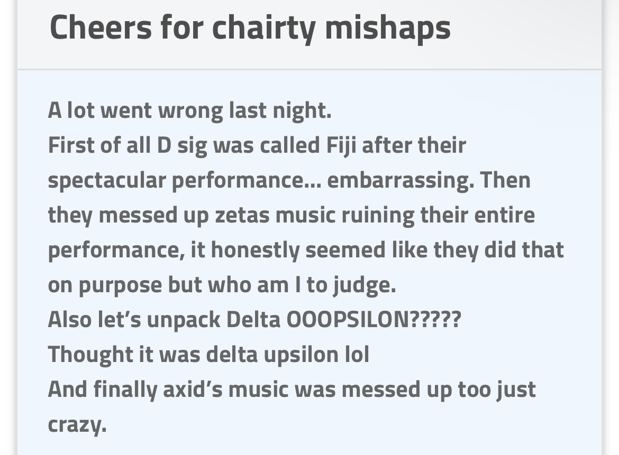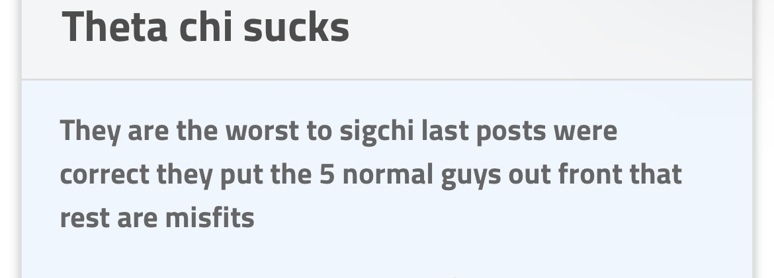
(“Cheers for charity mishaps”) (“Theta chi sucks”)
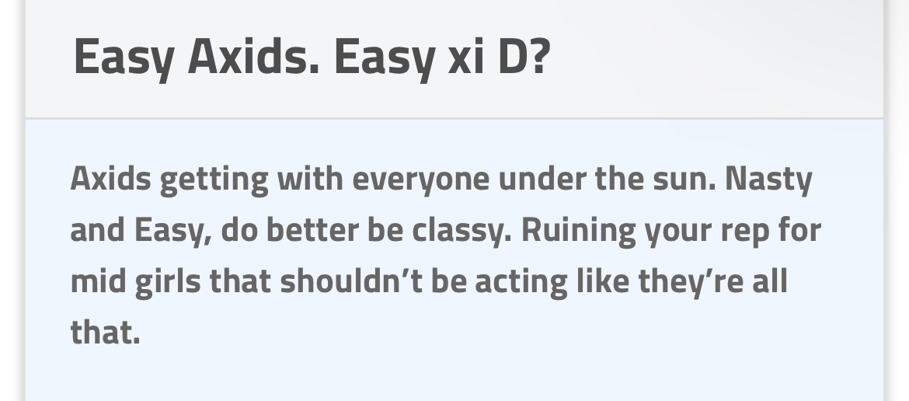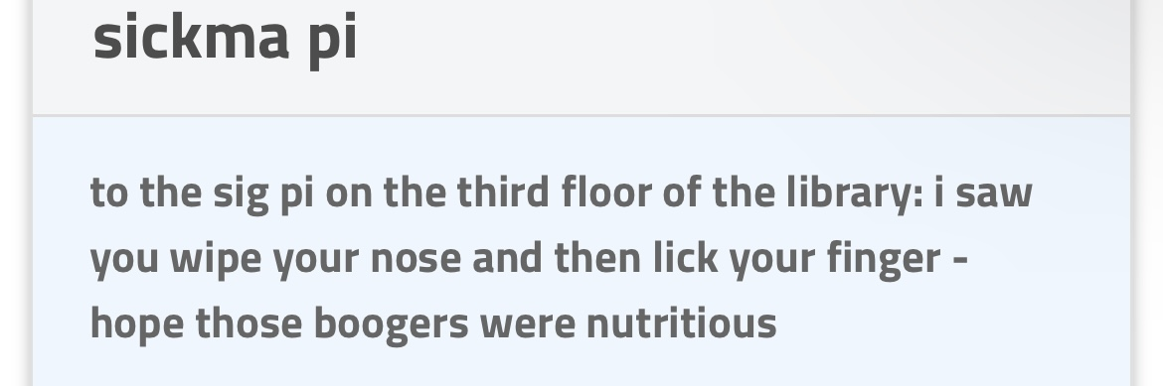
(“Easy Axids. Easy xi D?”) (“sickma pi”)
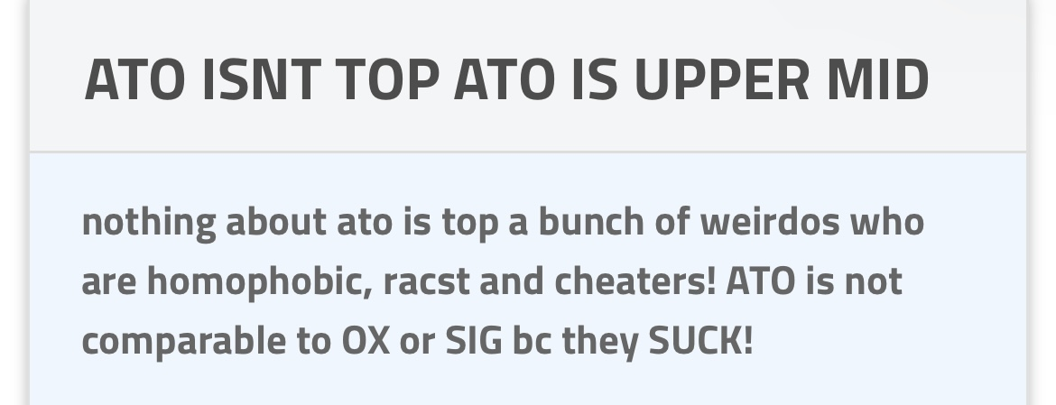 (“ATO ISNT TOP ATO IS UPPER MID”)
The purpose of all these comments is to bring certain sororities or fraternities down. Some comments are worse than others, but they all take it home in the aspect of hating and cyberbullying. I chose to put these comments in the same group since they all have a tone of hate and use negative words or slurs to offend these chapters.
Trying to combat hate/go against the norm
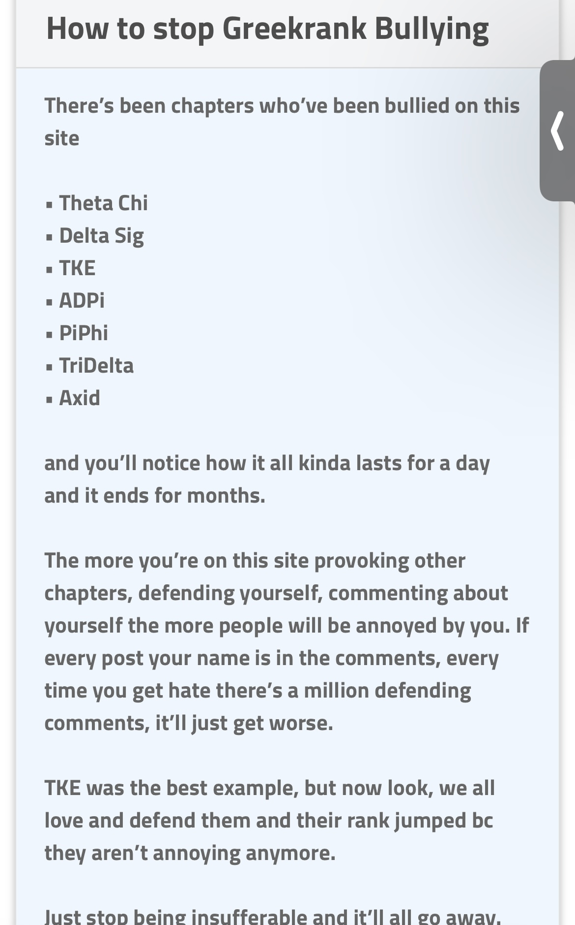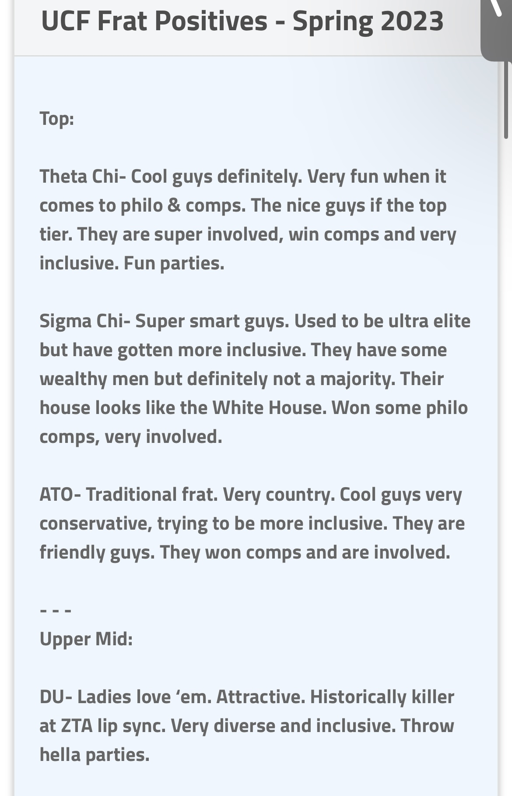
(“How to stop Greekrank Bullying”) (“UCF Frat Positives – Spring 2023”)
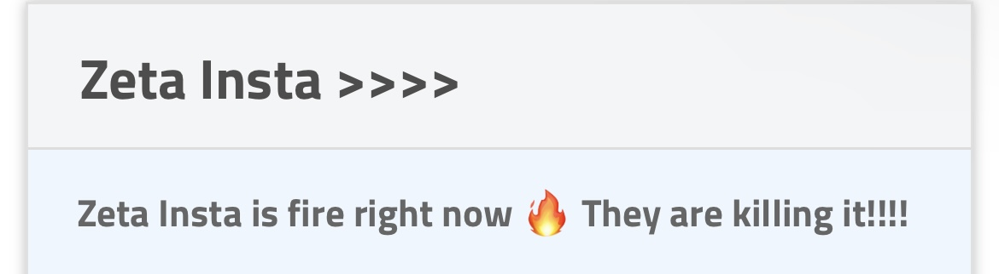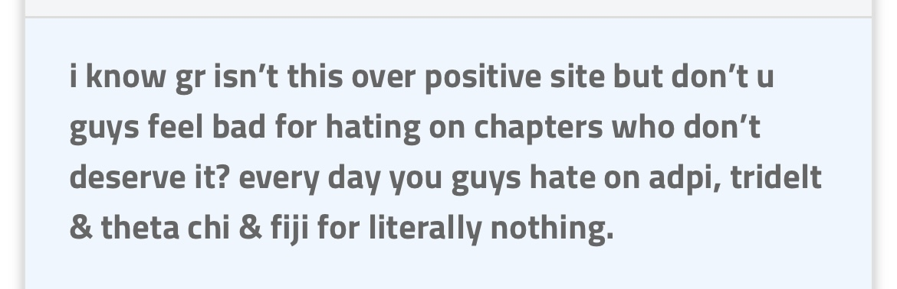 (“Zeta Insta >>>>”) (“about the adpi, tridelta, theta chi & fiji hate”)

The purpose of these comments is on the opposite side of the spectrum of the last comments shown since these are trying to spread positivity and stand up against the hateful narrative of GreekRank. This is very clearly shown in the last comment that starts with “I know gr isn’t this over a positive site but don’t you guys feel bad for hating on chapters who don’t deserve it?” The person who commented is already aware GreekRank isn’t a positive site which is why this comment goes against the norm. These comments all share the same theme of trying be more on the positive side. This is shown through comments such as “Zeta insta is fire right now.”
Information/actual news
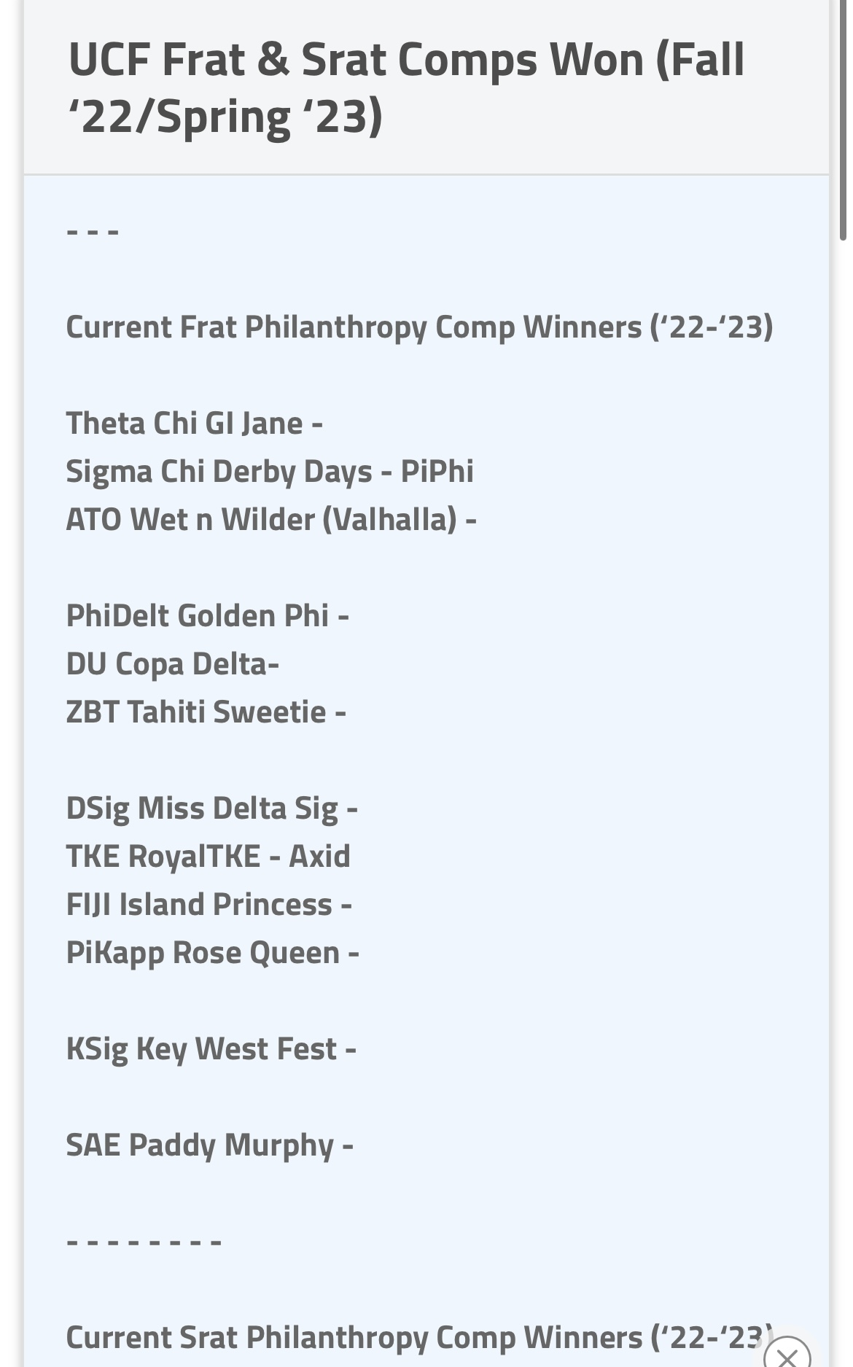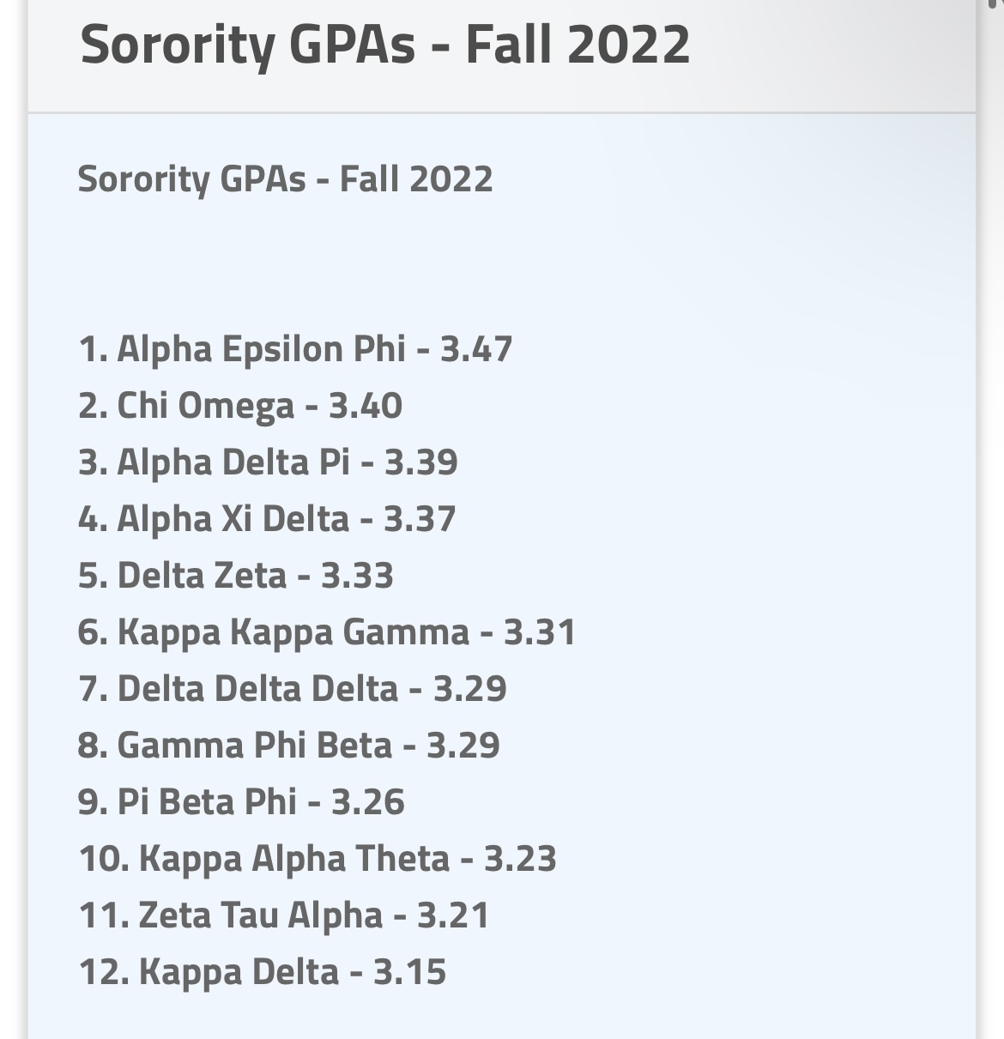
(“UCF Frat & Srat Comps Won (Fall ‘22/Spring’23”)
(“Sorority GPAs – Fall 2022”)
(“Srat Philanthropy Comp Winners”)

The purpose of these is to inform people about statistics and facts. There are very little of these posts which is ironic since the alleged purpose of GreekRank is to be a source for fraternity and sorority news & reviews, as shown in the picture below of when you first click on the website.
 (“Your Source for Fraternity and Sorority News & Reviews”)
Stereotypes/classifying
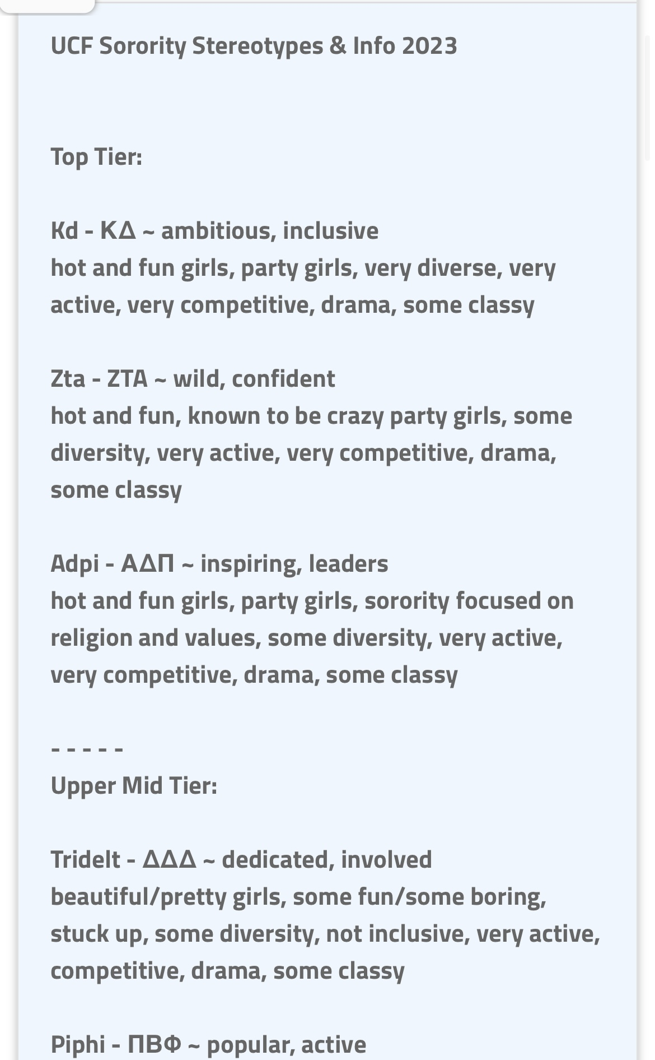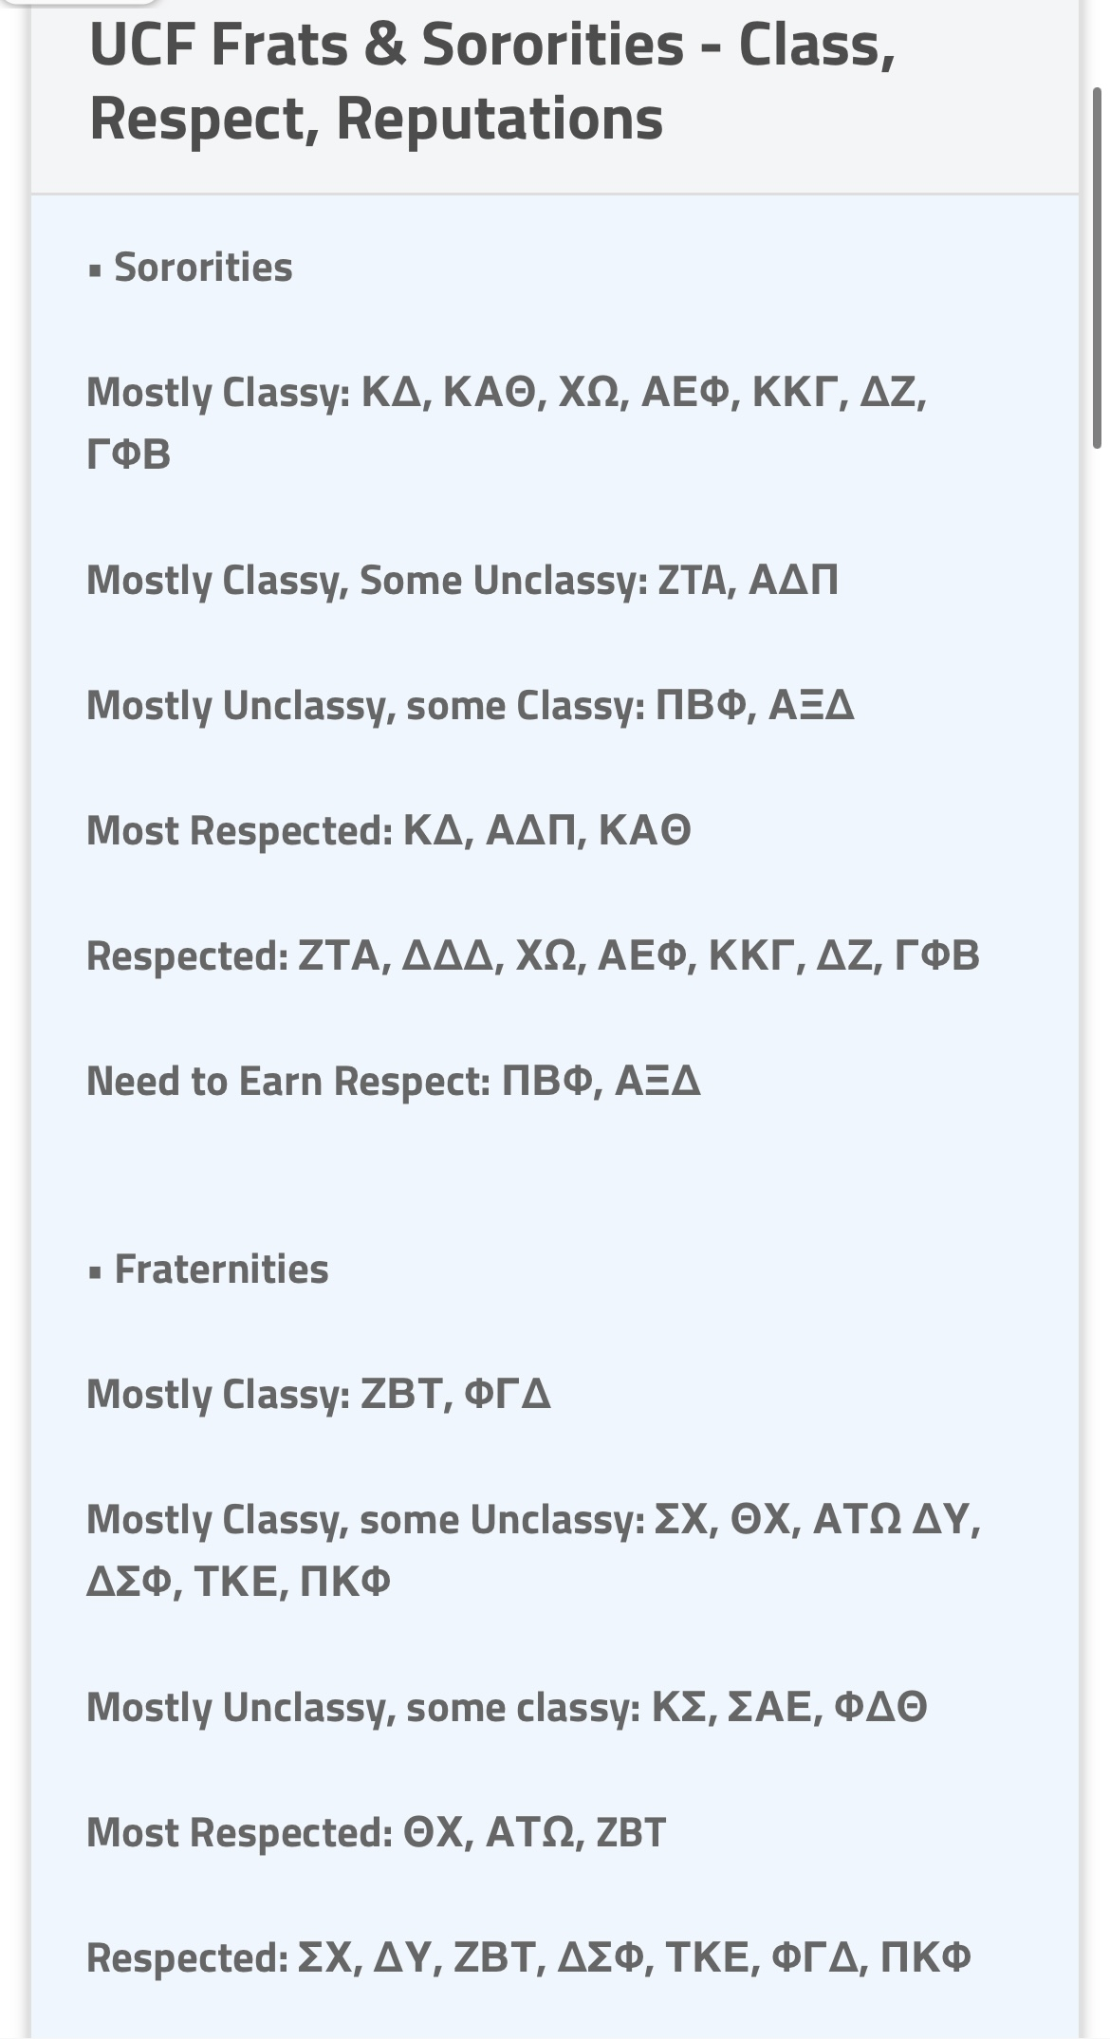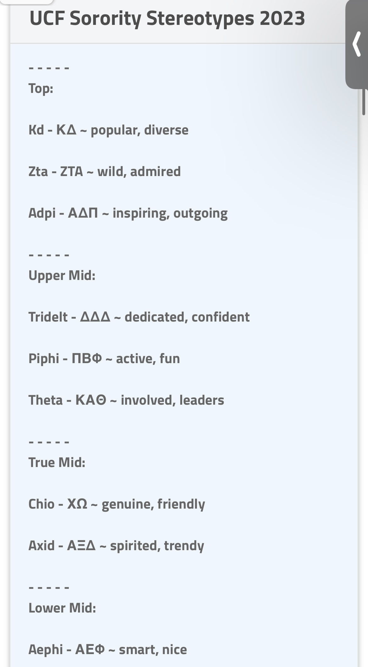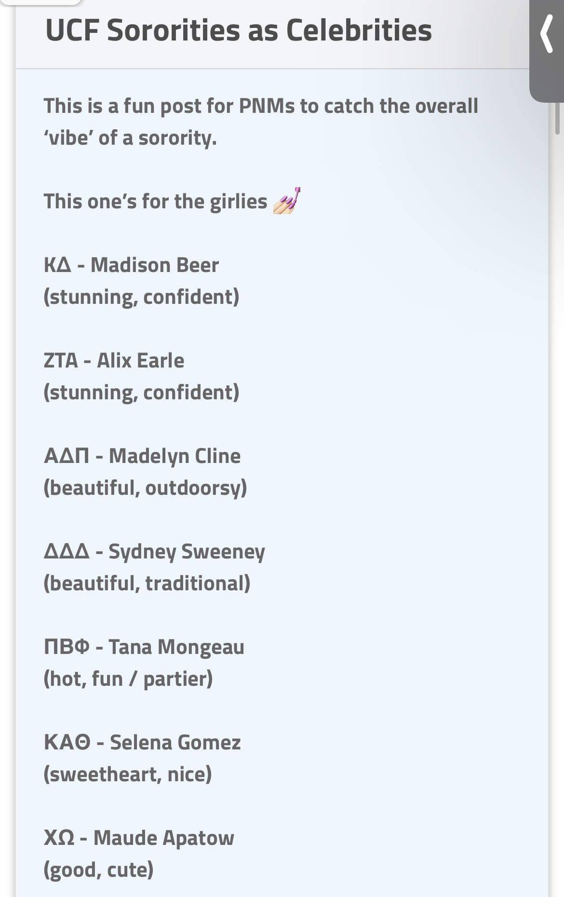
(“UCF Sorority Stereotypes & Info 2023”) (“UCF Frats & Sororities – Class, Respect, Reputations”)
(“UCF Sorority Stereotypes 2023”) (“UCF Sororities as Celebrities”)
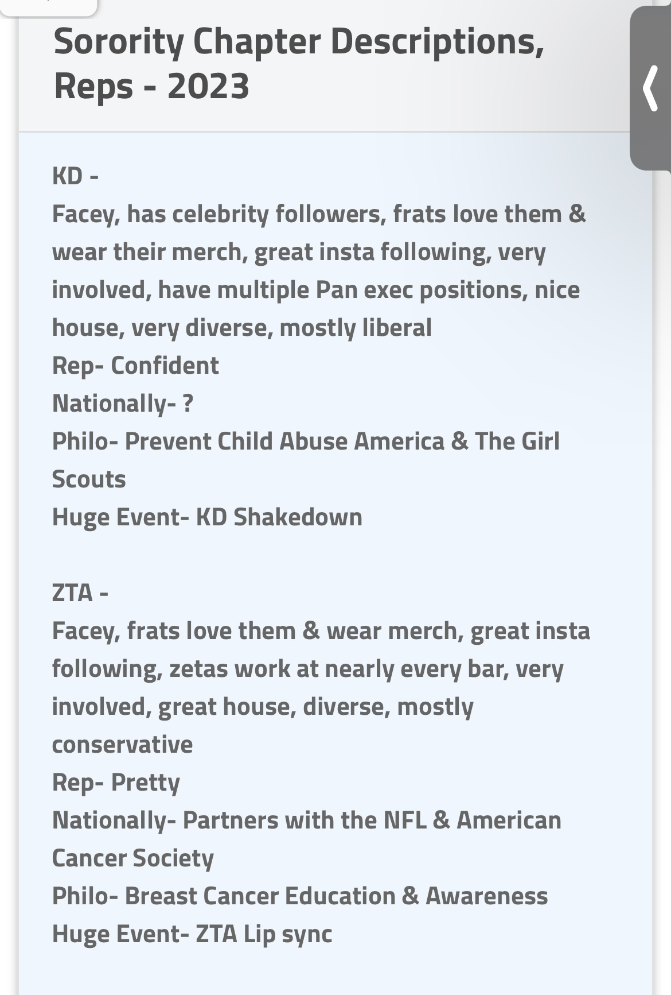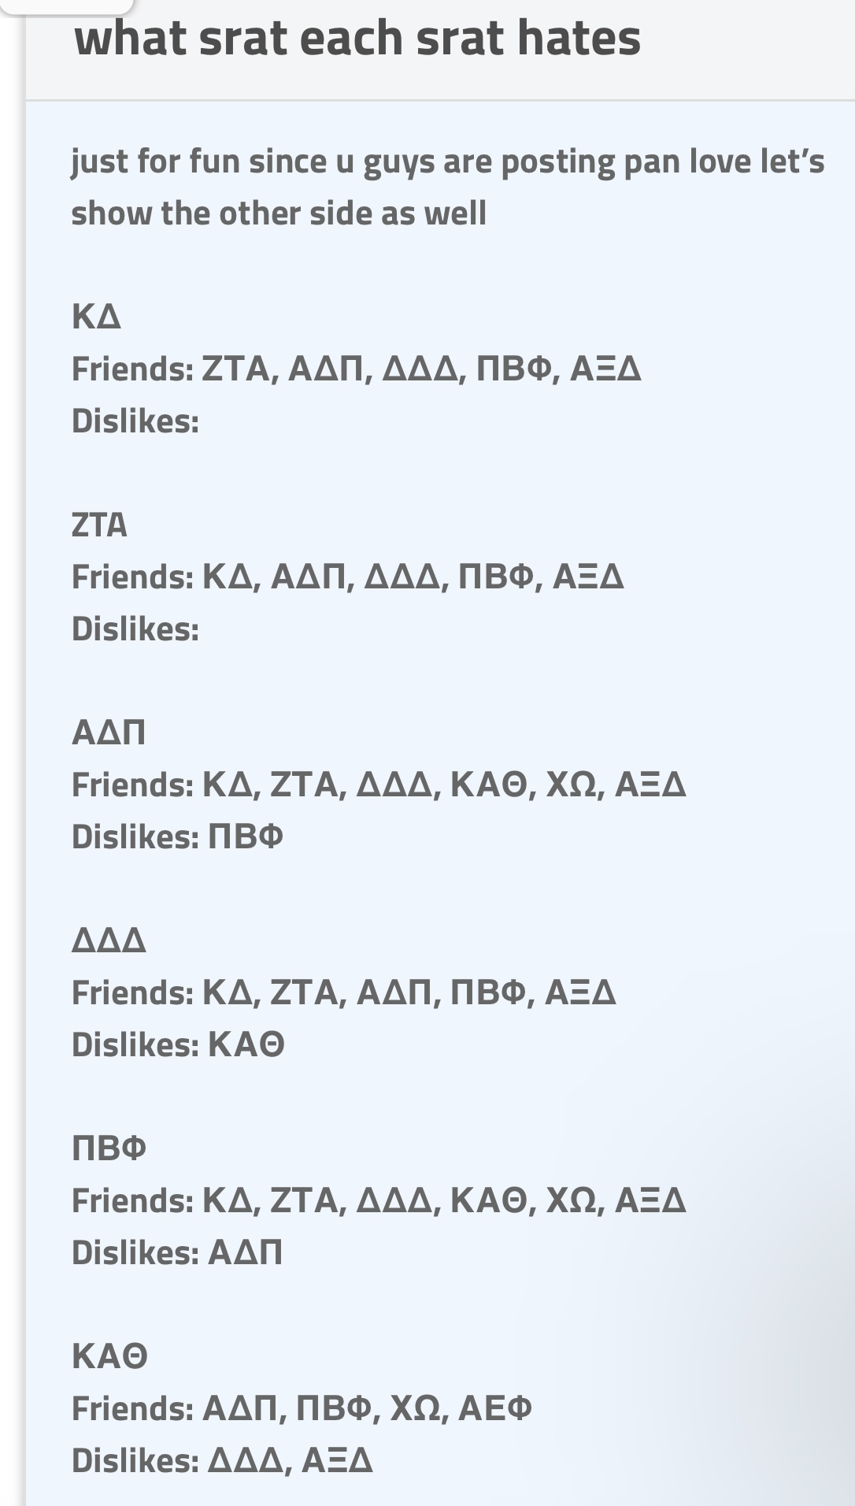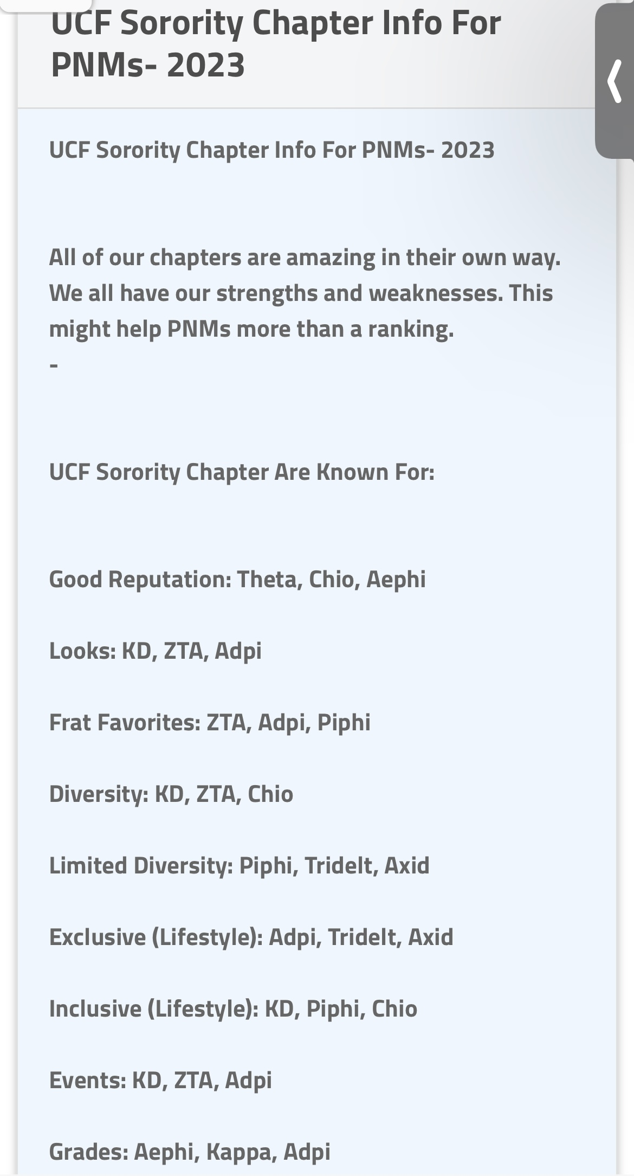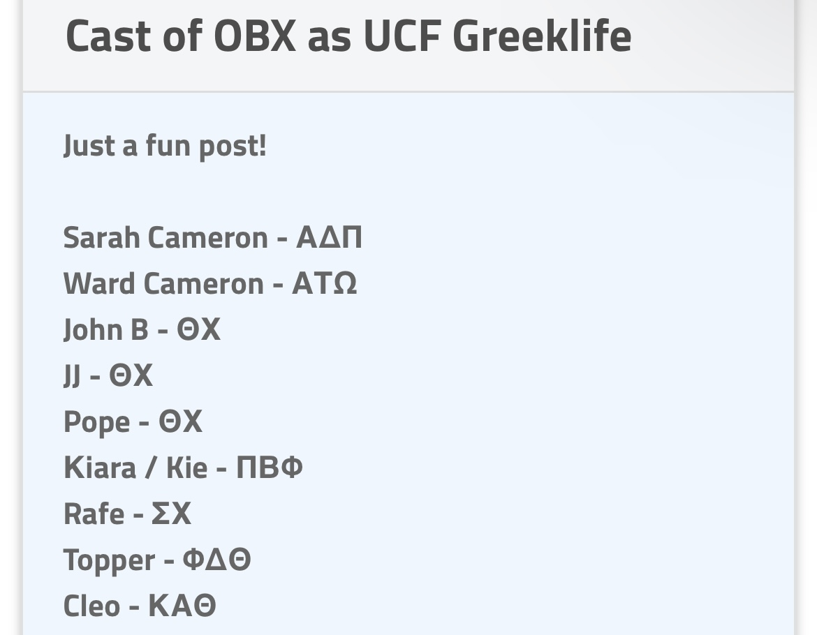
(“Sorority Chapter Descriptions, Reps – 2023”) (“what srat each srat hates”)
(“UCF Sorority Chapter Infro For PNMS – 2023”) (“Cast of OBX as UCF Greeklife”)
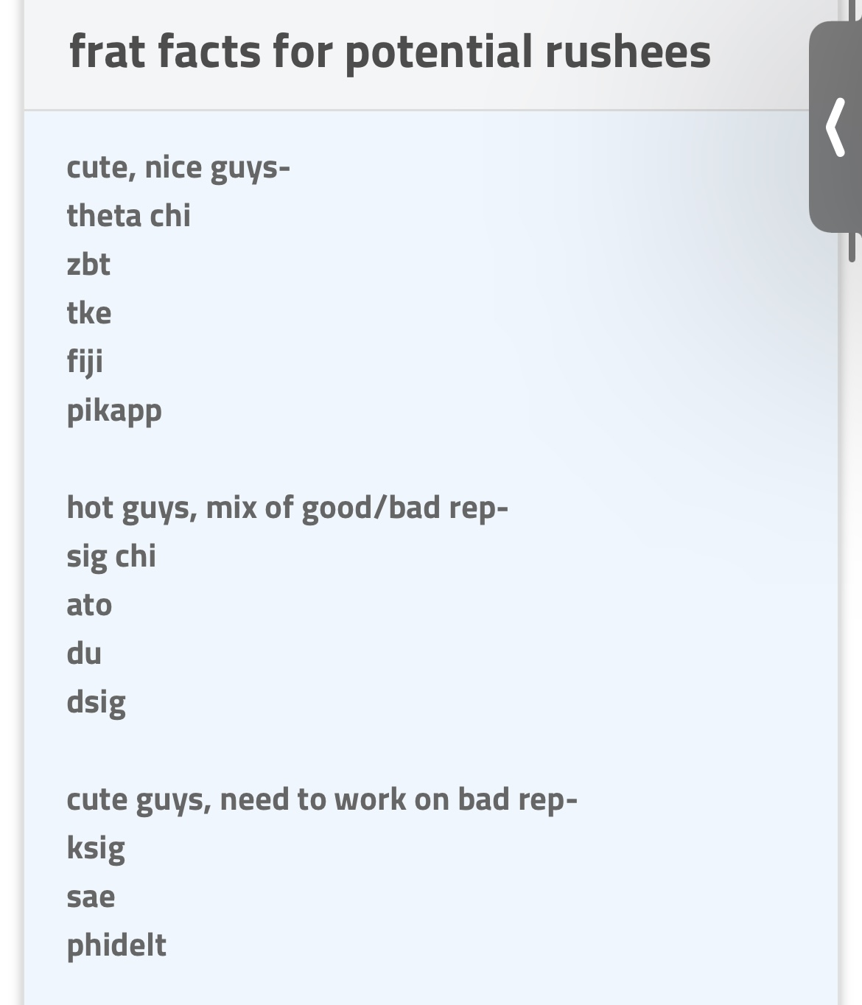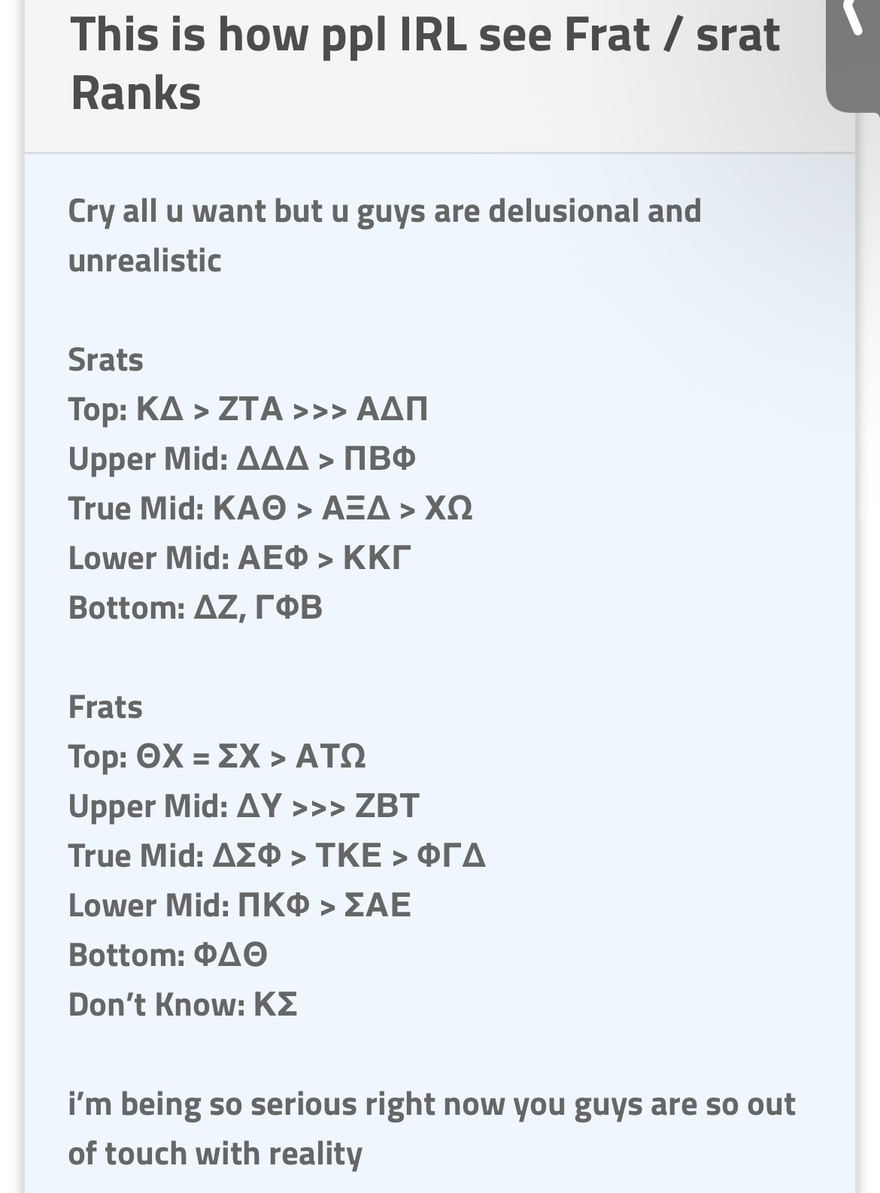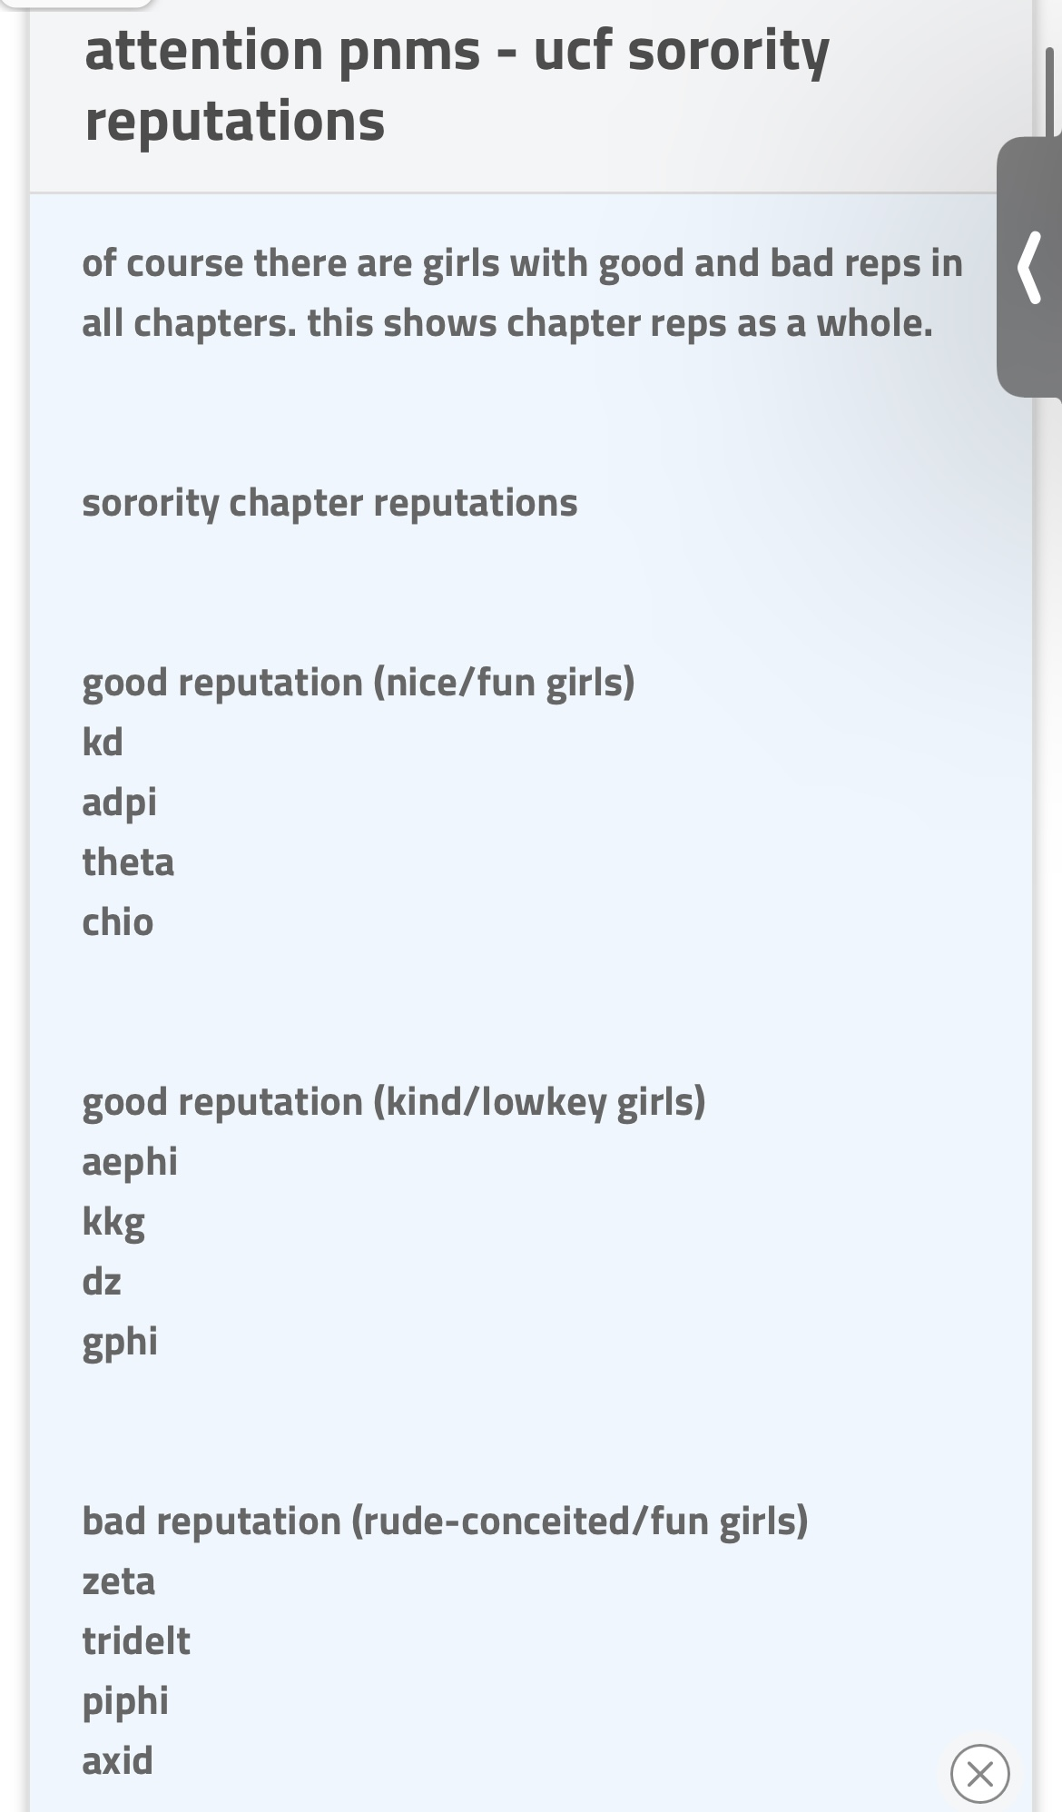
(“frat facts for potential rushees”) (“This is how ppl IRL see Frat / srat Ranks”)
(“attention pnms – ucf sorority reputations”) (“Cast of OBX as UCF Greeklife”)
The purpose of these posts is to entertain people with stereotypes of different chapters. Some are playful while some are more to the point but either way, they are still attaching stereotypes. I categorized these comments together since they all are assigning a stereotype to a chapter, whether that be positive or negative. You can usually see this in the title, such as “UCF Sorority Stereotypes 2023.” This post says it more obviously while some are more disguised like “Cast of OBX as UCF Greek life.”
Unnecessary Polls
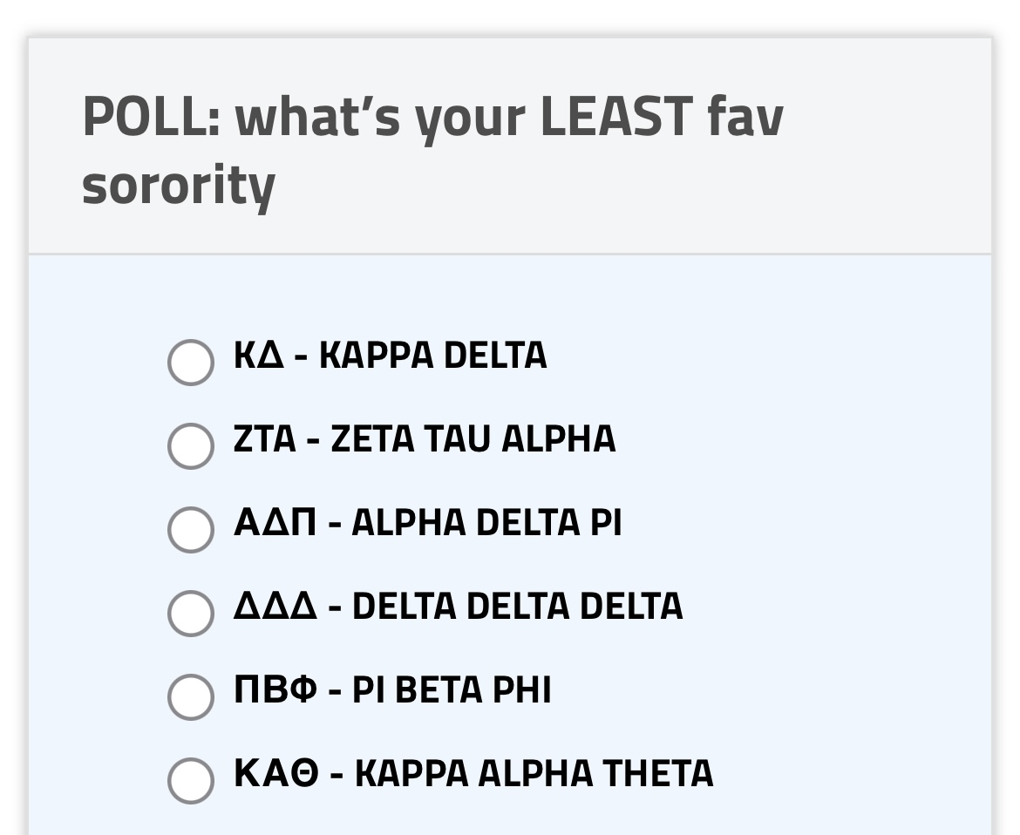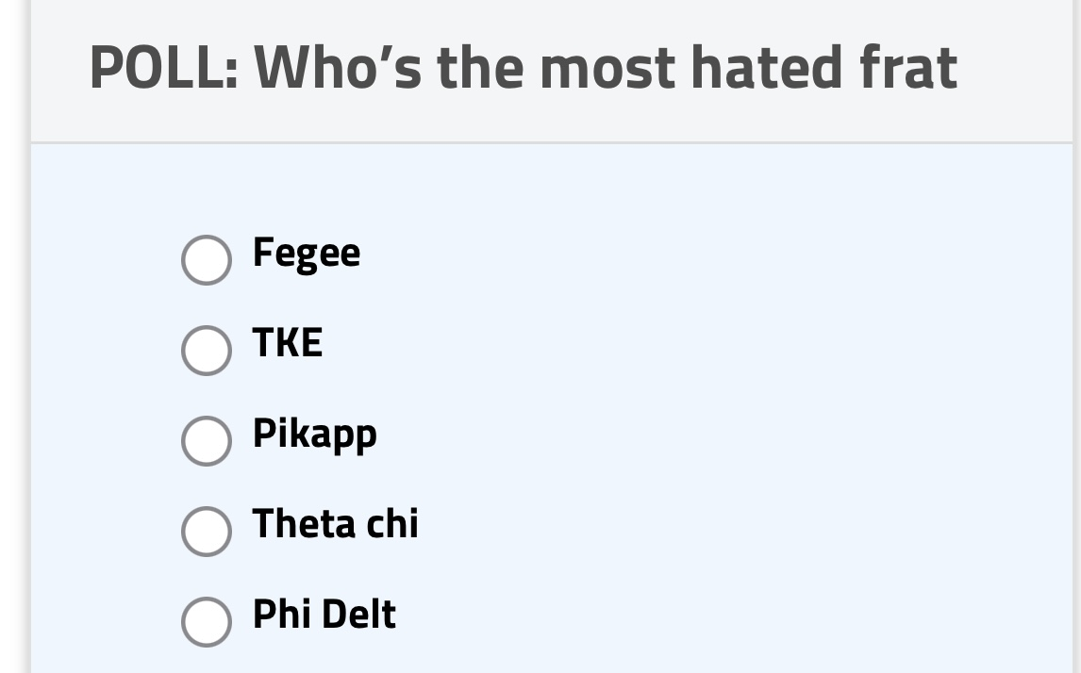
(“POLL: what’s your LEAST fav sorority”) (“POLL: Who’s the most hate frat”)
The purpose of these posts is a little different from the rest of the comments I collected, but still has the noted theme of spreading hate. Although these are in the discussion genre, they are a different genre than the rest of the comments I have surveyed since they are polls that people can vote on. These polls are unnecessary and inaccurate since no chapter is better than the other and it is purely based off opinion.

Discussion: Most of the comments found on GreekRank are either promoting hate or promoting stereotypes about chapters. This is what makes the website so popular and is what people feed into. My goal for this research was to show how this genre influences stereotypes and encourages hate and I feel as though my results showed perfectly how it does. The fact that I selected and analyzed thirty comments and only ten percent of those were about actual news shows that this genre has not stayed true to its purpose. It makes perfect sense that stereotyping and classifying has the largest number of comments and that it shows that GreekRank’s main purpose is to influence stereotypes.
Anonymity
People also enjoy that they can get away with unfairly assigning stereotypes to organizations with 100 to 200 people. It is crucial to note how the factor of anonymity can play a role in making this genre more toxic than if this factor didn’t exist. The genre would not exist if not for its anonymous users. This goes back to my research question of how GreekRank has enough power to influence stereotypes and spread hate. GreekRank has this power only because it places the user in a position of power the moment they comment. With their name and identity being secret, they take advantage of this and use it for the worst.
False stereotypes
Within the genre of comments another genre exists on almost every single page of GreekRank. That is the posts that fully are posted to stereotype sororities and fraternities for the goal of entertainment or even embarrassment. Now while some people may see nothing wrong with these posts and some posts may be less harmful then others, at the end of the day it is still GreekRank influencing stereotypes within UCF Greek life. The perceptions and generalizations of these organizations is highly limited judging that the stereotypes are not accurate since they could not possibly reflect every single person in a chapter. Most of the time these stereotypes are also not up to date and are outdated. This yet again proves how the genre influences stereotypes in a way that limits chapters to only be certain things when they have so much more to offer.
How this affects Greek Life
GreekRank does only exist online but with comments that have this much hate can have some weight, which in return can physically harm the chapter. In order to be in Greek life, you must go through a process known as recruitment. So, potential new members or PNM’s may come across these posts and be discouraged from joining a certain sorority or fraternity. Posts spreading rumors or false narratives about a chapter can also affect their standing or rank. This is because there is no way to confirm if something is true which also shows how GreekRank is an unreliable source for news, which therefore defeats the whole purpose of this genre existing and having an online presence. I know from firsthand experience, that it takes a lot of effort and willpower in order to make things happen in an organization apart of Greek life. So when all of the work that people put in behind the scenes into an organization like this gets overlooked for the sake of a rumor on GreekRank, it not only can harm the chapter but also shows how much power this genre has.

Conclusion:
The genre of GreekRank has grown to be too powerful and harmful to organizations involved in Greek life at UCF. A website should not have people in a chokehold and especially should not threaten multi-thousand organizations that have existed for hundreds of years. The data has proved how harmful this site can be if it wants to and also how useless it is in keeping people up to date on information. GreekRank has been proved from time and time again to be used for the bad and not at all the good. I note that this in the world we live in now and I respect it, but no website should interfere with traditional organizations as much as this one does. Condensing chapters down and belittling them also exemplifies why there is such a need for this website or genre to be taken down. As long as it exists, the wrong people are going to use it since they thrive off of anonymity and making themselves feel better.

Works Cited
“about the adpi, tridelta, theta chi & fiji hate.” https://www.greekrank.com/uni/68/topic/3474500/about-the-adpi-tridelta-theta-chi--fiji-hate-/, 9 Mar. 2023
“ADPI & PI PHI CHEATERS.” https://www.greekrank.com/uni/68/topic/3484142/adpi--pi-phi-cheaters/, 24 Mar. 2023
“adpi was ratchet downtown.” https://www.greekrank.com/uni/68/topic/3483689/adpi-was-ratchet-downtown/, 24 Mar. 2023
“attention pnms – ucf sorority repuations.” https://www.greekrank.com/uni/68/topic/3477817/attention-pnms---ucf-sorority-reputations/, 15 Mar, 2023.
“ATO ISNT TOP ATO IS UPPER MID.” https://www.greekrank.com/uni/68/topic/3462593/ato-isnt-top-ato-is-upper-mid/, 23 Feb. 2023.
Bagozzi, Richard P. “Multiple Routes for Social Influence: The Role of Compliance, Internalization, and Social Identity.” Social Psychology Quarterly, vol. 65, no. 3, 2002, p. 226., https://doi.org/10.2307/3090121.
“Cat of OBX as UCF Greeklife.” https://www.greekrank.com/uni/68/topic/3464098/cast-of-obx-as-ucf-greeklife/, 25 Feb, 2023.
“Cheers for charity mishaps.” https://www.greekrank.com/uni/68/topic/3473794/cheers-for-chairty-mishaps-/, 8 Mar, 2023.
“Current Frat Winners.” https://www.greekrank.com/uni/68/topic/3470176/current-frat-winners-srat-philo-comps/, 3 Mar, 2023.
“Easy Axids. Easy xi D?” https://www.greekrank.com/uni/68/topic/3482594/easy-axids-easy-xi-d-/, 22 Mar. 2023
“Fat Fiji Found.” https://www.greekrank.com/uni/68/discussion/, 26 Mar. 2023
“frat facts for potential rushes.” https://www.greekrank.com/uni/68/topic/3478720/frat-facts-for-potential-rushees/, 16 Mar. 2023.
“Frequently Asked Questions.” Frequently Asked Questions | SUNY Oswego, https://ww1.oswego.edu/student-engagement-leadership/fraternity-sorority-community/frequently-asked-questions.
Henderson, Alyssa N. Evaluating Stereotypes of University Greek Life. Iowa State University Digital Repository, 2017. Print.
Howell, Whitley W. “Exploring How Popular Media Affects the Motivations and Hesitations of Women Who Go through Sorority Recruitment at the University of Southern Mississippi.” The Aquila Digital Community, https://aquila.usm.edu/honors_theses/784/.
Marro, Victoria. The Genres of Chi Omega: An Activity Analysis, 2021, https://cah.ucf.edu/writingrhetoric/wp-content/uploads/sites/27/2019/10/stylus_3_1_Marro.pdf.
“Poll: what’s your LEAST fav sorority.” https://www.greekrank.com/uni/68/topic/3478804/poll-whats-your-least-fav-sorority-/, 17 Mar, 2023.
“Poll: Who’s the most hated frat.” https://www.greekrank.com/uni/68/topic/3468067/poll-whos-the-most-hated-frat-/, 1 Mar, 2023.
“sickma pi.” https://www.greekrank.com/uni/68/topic/3475147/sickma-pi-------------------/, 10 Mar. 2023.
“So many piphi posts BFFR.” https://www.greekrank.com/search.php?q=so+many+piphi+posts+bffr, 20 oct. 2022.
“Sorority Chapter Descriptions, Reps – 2023.” https://www.greekrank.com/uni/68/topic/3453331/sorority-chapter-descriptions-reps---2023/, 11 Feb, 2023.
“Sorority GPAs – Fall 2022.” https://www.greekrank.com/uni/68/topic/3455427/sorority-gpas---fall-2022/, 14 Feb, 2023.
“Theta chi sucks.” https://www.greekrank.com/uni/68/topic/3464681/theta-chi-sucks--/, 26 Fed, 2023.
“This is how people IRL see Frat / srat Ranks.” https://www.greekrank.com/uni/68/topic/3476225/this-is-how-ppl-irl-see-frat--srat-ranks/, 12 Mar, 2023.
Thompson, Bailey A. “Frat Daddies and Sorostitutes: How Totalfratmove.com and Greek Identity ...” Sexualization, Media and Society, Sage Journals, 20 Dec. 2016, https://journals.sagepub.com/doi/10.1177/2374623816684691.
Toomey, Payton. “Opinion: Greekrank Is a Toxic Hellscape of Objectification.” The Daily Wildcat, 17 Mar. 2021, https://www.wildcat.arizona.edu/article/2021/03/o-greekrank-problems.
“University of Central Florida – UCF Discussion.” www.ucfgreekrank.com

“UCF Frat Positives – Spring 2023.” https://www.greekrank.com/uni/68/topic/3429516/frat-positives---spring-2023/, 23 Jan. 2023
“UCF Frats & Sororities – Class, Respect, Reputations.” https://www.greekrank.com/uni/68/topic/3484211/ucf-frats--sororities---class-respect-reputations/, 25 Mar, 2023.
“UCF Frat & Srat Comps Won ( Fall ‘22/Spring ’23.” https://www.greekrank.com/uni/68/topic/3493505/ucf-frat--srat-comps-won-fall-22spring-23/, 7 Apr, 2023.
“UCF Sororities as Celebrities Updated.” https://www.greekrank.com/uni/68/topic/3471947/ucf-sororities-as-celebrities-updated-/, 6 Mar, 2023.
“UCF Sorority Chapter Info For PNMs- 2023.” https://www.greekrank.com/uni/68/topic/3404951/ucf-sorority-chapter-info-for-pnms--2023/, 7 Jan, 2023
“UCF Sorority Stereotypes 2023.” https://www.greekrank.com/uni/68/topic/3479502/ucf-sorority-stereotypes-2023/, 18 Mar, 2023.
“UCF Sorority Stereotypes & Info 2023.” https://www.greekrank.com/uni/68/topic/3388451/ucf-sorority-stereotypes--info-2023/, 13 Dec, 2022.
“what srat each srat hates.” https://www.greekrank.com/uni/68/topic/3483488/what-srat-each-srat-hates/, 24 Mar, 2023.
“Your Source for Fraternity and Sorority News & Reviews.” www.greekrank.com
“Zeta Insta >>>>.” https://www.greekrank.com/uni/68/topic/3482982/zeta-insta-/, 23 Mar. 2023.

